

**ETHEREUM ARCHITECTURAL DESIGN PATTERNS –**

**CONTRACT FACTORY WITH NAME REGISTRY**

Date: 12/04/2018

Brent Anthony Tudas

Sandra Alleine Blanca

Jaymar Dingcong

Robert Aries Dela Paz

Kimberly Mae Reyes

Patrick Oliver Palmero

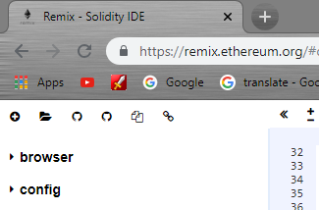**INSTRUCTIONS**

Go to <https://remix.ethereum.org/>

1. Click the icon and go to the folder

Directory of this document and select

LandFactory.sol and Registry.sol

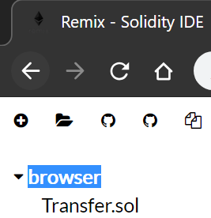

1. Click “browser” and it will collapse  
   find “LandFactory .sol” and select it.





1. 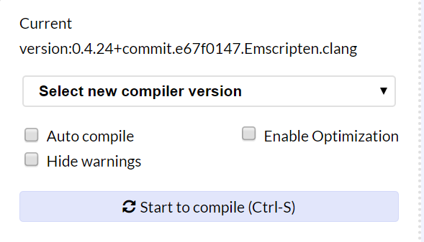Select new compiler version. Set it to 0.4.24+commit version.

Then, select Run tab.

1. Select ***Environment*** change itto JavaScript VM.
2. Select **Account** from the drop down button. Remember you chosen account.
3. 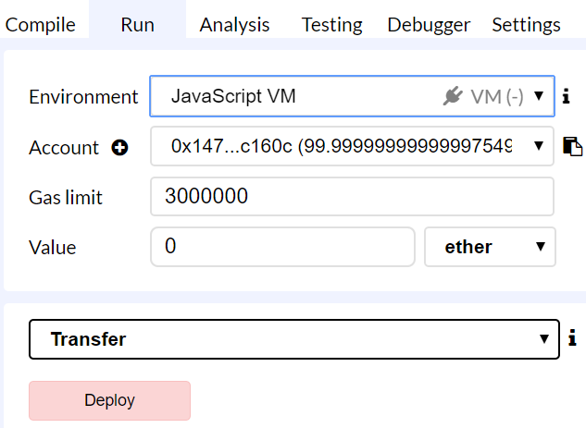 Click **deploy**.

**Deploying the Contract**

Make sure you select LandFactory then hit deploy.

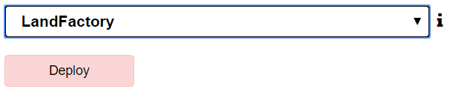

**Adding a Land**

Find the andLand field and provide the inputs. First is the name of the land followed by its location then its coordinates then its area and finally the address of the landowner.

Ex. “ "Uma", "Jaro", [2, 5], 3, 0xca35b7d915458ef540ade6068dfe2f44e8fa733c ”



**Getting a Land by Owner**

Find the getBook field and put the address of the landowner. It will result to the address of the created land contract. Make sure to copy the result.

PS: Don’t follow the examples of addresses here because you will have different addresses.

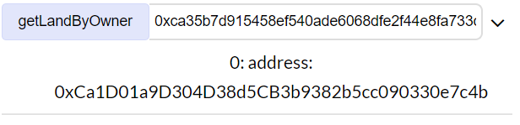

**Getting the data of the Land Contract.**

Go back to the deployment pane and switch it from LandFactory to Land. Paste the copied address in the field “At Address” and click it.

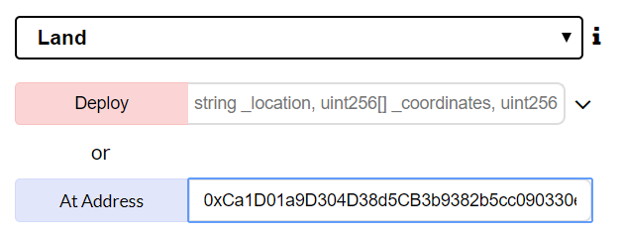

Go back to the deployed contracts and expand the newly added contract. It should look something like this.

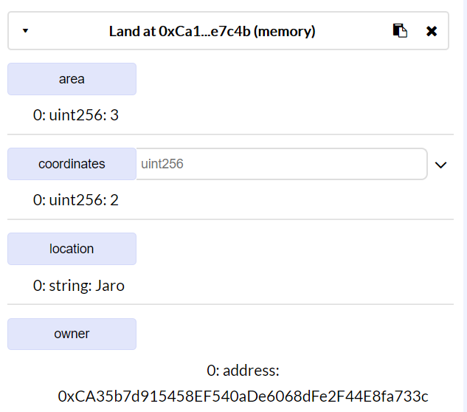

**Getting the Contract from Name Registry**

Find the getContractFromRegistry field and provide the name of the land. You will have the following results. First is the owner of the contract followed by the address of the contract.

